Open Anaconda prompt:
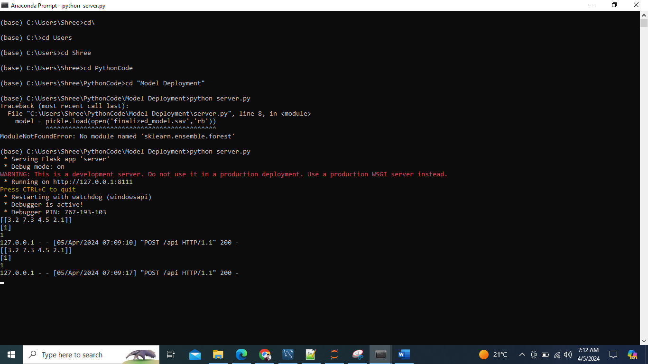
Now code written in server.py is running. Means service is running now we just need to call this.
Open another Anaconda prompt:
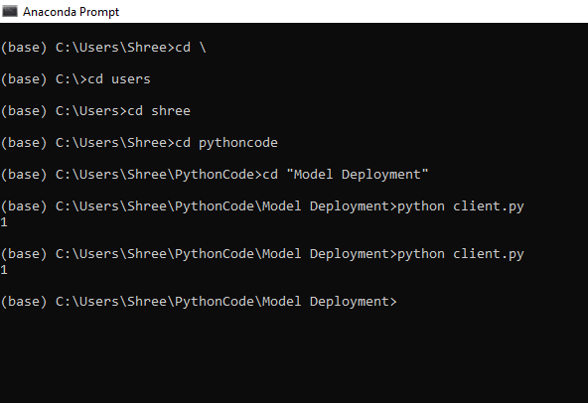
We can see it is predicting class as 1 for the input given in client.py
=================================================================================
Install docker:
docker pull ubuntu - to download the image of ubuntu for containerization

